Name
Tutor
Course
Date
Reflective Writing on Class, Race & Hyper- incarceration in Revanchist America

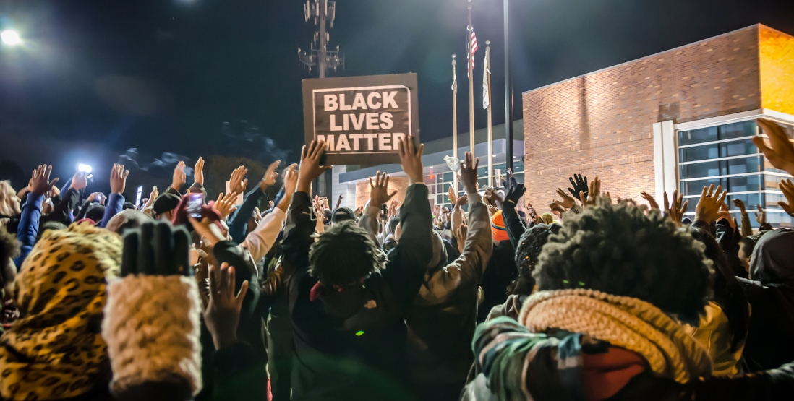
Fig 1.1 a picture of people rioting against racism
The Implication of the Picture
The above photo shows people united to protest against issue of racism. In the context of the United States of America, racial discrimination has been an issue of concern over several decades. The significant victims of racism are the African-Americans, due to their black skin color. There has been an association of blackness to poor intellectual capacity. The blacks are viewed as inferior in many social settings, and to some extent, this is initiating racial disparities. People get united towards fighting a common enemy of progress, and in this case, the enemy is racial discrimination of the African- Americans (Wacquant 81). Racism impacts negatively on the growth of a countries economy and thus needs to be eliminated. The picture is related to racism on the African-Americans as evident in the article “Class, Race & Hyper- incarceration in Revanchist America” by Loïc Wacquant. The police used force on blacks as opposed to the whites.
Author’s Theses
There are so many stereotypes about the people of African-American origin. Some of these stereotypes were borrowed from the colonial period implying that the blacks were only good at causing violence. Additionally, blacks are viewed as criminals, and this shows analogy in reasoning. Majority of the whites focus on discriminating the African-Americans community and also associate them with violent crimes. The blacks occupied the American police, courts, and prison. Some may have committed crimes and other my not (Wacquant 70). However, the judicial sector depicts that racial discrimination by giving unfair judgment towards the blacks. Civil rights movements mobilize people to observe fairness in treating people, thus eliminating the issue of social class, race, and incarceration.
Summary of the Article
The article “Class, Race and Hyper incarceration in America” presents ideas on the happenings and the history of specific incidences in the United States of America. There is downsizing of welfare activities and the upsizing of criminal justice wing of American states due to poverty and crimes. Stigmatization is also evident in nations (Wacquant 79). The police were getting much involved in curbing crimes, although they targeted specific groups of people, especially blacks. Additionally, the U.S used incarceration to delay civil riots movement and riots; this was marked by a significant increase in the number of people getting imprisoned. The article indicates that increasing the rate of arresting people who commit crimes reduced the number of social crimes (Wacquant 82). However, it is evident that prisons were ghettoized, meaning that they composed of the African-American people at large.
The United States government was getting more responsive to its citizens. This responsibility is shown in 2001 when it provided for the needy families impacting on about six million beneficiaries. All the groups of people and races; including the African-American and Hispanic –Americans had their needs attended to, and the idea of equality was making more sense across all races (Wacquant 81). Hyper-incarceration helped advocated for the upsizing of the social wing rather than the frequent imprisonment. Revanchism policy supported the issue of Hyper-incarceration and hyper-ghettoization (Wacquant 83). The argument behind this is that workforce and prison-force damage the society and the state. The article has a definite ending proposing that fighting social inequality and ethnicity should be coupled with social, economic, and judicial fairness. This will bring about positive change in the society and the nation.
Example to Support the Thesis
Absence of justice and fairness was a common characteristic on the U.S judicial systems. For instance, if two people, a black and a white committed the same crime, then subjected in a legal order for judgment, the probability that the two will receive similar court sentence was low, especially if the judge was white. There is a mentality of black people are messy and chaotic than the whites which ruled most of the social sectors. I tend to believe that racial discrimination is due to the desire of the whites to remain superior to the white (Wacquant 90). On the other hand, blacks are fighting for their freedom and equality in the social sectors. However, people are currently acknowledging that racial discrimination results in more harms than benefits.
The empirical case that the author presents to support the thesis statement is that a lecturer was criticized for having a class of six black students. This scenario implies that the African-Americans struggled with racial discrimination for a long time. Additionally, the prisons were comprised of blacks (Wacquant 81). Literally, this would infer that blacks got much involved in social crimes than whites. I believe that blacks were trying to demand their freedom and the end of racial discrimination. The U.S government was rampant on curbing the attempts of the civil rights movement and thus limiting freedom of the minority ethnic groups.
Reflection of the Scenario to Personal Experience
The article shows the criticism that happens in real life. Many people are discriminated on various dimensions like racial discrimination and ethnicity. In my own experience, I witnessed racial discrimination while watching a live football game. When a black player makes a mistake, then he or she is associated with a monkey. On the other hand, a white player makes the same mistake, but the fans seem okay with that. This shows the extent of racial stereotypes and misinformation in many social sectors.
Form another perspective; the blacks are somewhat violent. Most of the street thieves and robbers are blacks. The culture of ghettos still exists among some people in the world and there is the notion that the blacks form violent groups, commonly known as gangs whose primary intention is to deter peaceful co-existence among people. Additionally, I have observed that the many violent groups have more African-American teenagers than European American teenager. The incidences of homicide are also familiar with blacks. I think the law has been taking its course to punish the black offenders by offering them a fair judgment reflecting on the intensity and nature of their crimes. I believe social violence limits peaceful co-existence among the people.
Reflection of the Lecture Studies to the Article
The article on “Class, Race, and Hyper-incarceration in Revanchist America” addresses common social problems affecting society today. Moreover, it reflects the readings made in-class lectures. Racial segregation is prevalent in social set up. In the course of our studies, we acknowledged that in the areas habited by whites were preserved of the white only. In the case scenario, a black lady made a call to the white landlord demanding to rent a house. The landlord seemed to agree to rent his apartment to the lady. However, when he saw the black lady, he argued that all the apartments had been occupied. This scenario shows that there so many stereotypes and beliefs regarding people of different racial origins. Social inequality is also evident in the article. The roots of social inequality are the uneven distribution of resources within a society (Wacquant 82). The poor people are subjected to poor and low-quality services since they have low claiming power than high social class people.
When social problems touching the lives of many people occur, social movements are the most preferable for the public to air their grievances to the government. For example, in the picture provided on the cover page, people are united towards the issue of racial discrimination (Wacquant 81). The common grievance is equality between the white and the blacks since all of them are human. Social movements are founded on the need to fight for civil rights. However, the government does not always react positively to the social movement. For example, in the article “Class, Race, and Hyper-incarceration in Revanchist America,” the government devices a strategy of curbing civil movements by imprisoning the leaders and the organizers of the black movement in ghetto ended up in prison and thus reducing the incidences of violence and criminal activities (Wacquant 74). In reflection, there is a more significant relationship between the lecture lessons and the real happening in the society as argued in the article.

Works cited
Wacquant, Loïc. "Class, race & hyperincarceration in revanchist America." Daedalus 139.3 (2010): 74-90.

